Windows commands and software used in this worksheet are documented below. Each command has a link were additional information can be obtained to further understand the command features.
Command | Description | Link | Appendix
ipconfig | Default Windows command used to configure IP (internet protocol configuration). | http://ss64.com/nt/ipconfig.html | Help
net | Default Windows command used to manage File Shares, Printer Shares and sessions. | http://ss64.com/nt/net_share.html | Help
browstat | Default Windows command used to get domain, browser and PDC info. | http://ss64.com/nt/browstat.html | Help
enum | Free downloadable command line utility used to enumerate information over a Null Session. | http://www.darkridge.com/~jpr5/code.html | Help
Dumpsec | Free downloadable GUI and command line utility used to enumerate information over a Null Session. | http://www.systemtools.com/somarsoft/
nbtscan | Free downloadable command line utility used to enumeration Windows workstation and server NetBIOS information by conducted a scan of an ip address range. | http://unixwiz.net/tools/nbtscan.html | Help
getacct | Free downloadable GUI utility used to enumeration Windows users without a Null Session connection. | http://www.securityfriday.com/tools/GetAcct.html

Task | Steps and Description | Initials | Date | Linked  Results
1 | Document the connection to the networked Windows environment. From the assessor workstation, attached to the network that is being assessed, open a command window and obtain the network interface information.  C:\>ipconfig /all  This is a default Windows command.  This command will show you the ip address, subnet, hostname, DNS, DHCP, WINS information. |  |  | EV1
2 | Document the Domain and Workgroups in the networked Windows environment. From the Windows command prompt type the following command:  C:\>net view /domain > client.domains.txt  This is a default Windows command.  This command will show you all the workgroup and Windows domains in the environment. The command also saves the information to a file. It will be used later for additional enumeration. |  |  | EV2
3 | Document the Domain and the Device Transport the assessor workstation is attached to. From the Windows command prompt type the following command:  C:\>browstat sta > client.browstat.sta.txt  This is a default Windows command.  This command will show you the Domain you are connected to as well as the Device Transport (your interface ID). The Device Transport will be used in additional browstat command tasks. |  |  | EV3
4 | Document the Domain Controllers for the Domains identified including the Domain the assessor workstation is attached to.  C:\>browstat gp \Device\NetBT_Tcpip_{RANDOM_NUMBER} <DOMAIN_NAME>  This is a default Windows command.  This command will identify the Domain Controller you specify in the command. To quickly identify this information for all the domains obtained in Task 2 we will run the command through a loop.  C:\>for /f %i in (client.domains.txt) do @echo %i >> client.pdc.txt && browstat gp \Device\NetBT_Tcpip_{RANDOM_NUMBER} %i >> client.browstat.pdc.txt  This will go through the client.domains.txt file and attempt to obtain the host name for the Domain Controller. If you do not have access to the domain or if it is a workgroup the command will produce an error. |  |  | EV4
5 | Document the services and Operating Systems of all the Windows workstations and servers in the respective Domain and Workgroup.  C:\>browstat vw \Device\NetBT_Tcpip_{RANDOM_NUMBER} <DOMAIN_NAME> > client.browstat.vw.<domain_name>.txt  This is a default Windows command.  To quickly identify this information of the workstations and servers for all the Domains we will run the command through a loop.  C:\>for /f %i in (client.domains.txt) do @echo %i >> client.browstat.vw.txt && browstat vw \Device\NetBT_Tcpip_{RANDOM_NUMBER} %i >> client.browstat.vw.txt  You can also create separate files for each Domain/Workgroup.  C:\>for /f %i in (client.domains.txt) do @echo %i >> client.browstat.vw.%i.txt && browstat vw \Device\NetBT_Tcpip_{RANDOM_NUMBER} %i >> client.browstat.vw.%i.txt  This will identify any machine that is offering Windows services. This can include Unix/Linux servers running SAMBA. |  |  | EV5
6 | Document a Null Session connections to the Domain Controllers identified in Task 4. For additional information regarding a Null Session visit this website: http://www.securityfocus.com/infocus/1352  C:\>net use \\<PDC_MACHINE_NAME>\IPC$ "" /u:""  The command completed successfully.  The success of this command does not mean that a full access Null Session is allowed. Once the connection is made a command line utility needs to be used to extract some of the information that a Null Session can reveal (i.e. password policy, user and group information).  If a Null Session is unsuccessful an assessor can still obtain the information detailed in the tasks below. They will just have to use a valid Domain account. Obtaining a Domain account depends on the engagement. You can obtain one by asking the client to create an account for you. You can also obtain one by identifying a valid account and cracking the password using additional tools and testing detailed in the Windows Password Cracking worksheet. |  |  | EV6
7 | Document the Domain Controller password policy over a Null Session connection using the command line utility enum.  C:\>enum –P <DC_MACHINE_NAME>  A successful result will show a full Null Session vulnerability exists and detail potential password policy weaknesses. This utility can be used to extract additional information such as Domain users and Groups but there is a better tool for that detailed below. |  |  | EV7
8 | Document the Domain users and groups using the command line options for the tool DumpSec. Connect to the Domain Controller using the step detailed in Task 6.  C:\>dumpsec /rpt=users /computer=<DC_MACHINE_NAME> /outfile=client.dc_machine_name.userfile.csv /saveas=csv  C:\>dumpsec /rpt=groups /computer=<DC_MACHINE_NAME> /outfile=client.dc_machine_name.groupfile.csv /saveas=csv  Analysis of these documents reveals a lot of information regarding the user environment. The best way to analyze the information is with a database or MS Excel 2007. With a moderate to large domain you will exceed the 65,536 row limit of previous versions of Excel or any other spreadsheet application. |  |  | EV8
9 | Optional  Document the Domain workstation and server NetBIOS information by conducting an ip address range scan using nbtscan. This scan will identify all domain controllers in the environment.  C:\>nbtscan 10.0.0.0/16 –o client.nbtscan.10.0.txt  You can get information regarding the ip address ranges in your environment from the step in Task 1. |  |  | EV9
10 | Optional  This task is conducted if you want to enumerate Domain user accounts but Null Session is not allowed against the Domain Controller (and you don’t have a Domain account). Account enumeration is still possible using the utility GetAcct.  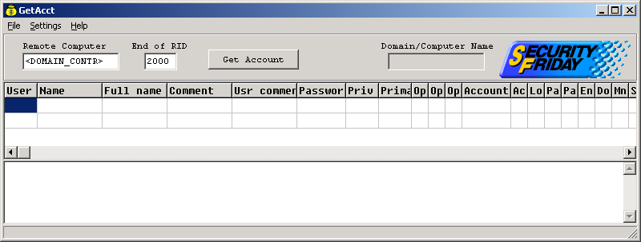  Enter the name or ip address of the Domain Controller and set the limit for the RID. Click Get Account and wait for it to enumerate the accounts. |  |  | EV10

EV1 – IPCONFIG Results (example) (Task 1)
If you are assigned a hostname it can help in identifying the naming scheme for the workstations.
C:\>ipconfig /all

Windows IP Configuration

Host Name . . . . . . . . . . . . : MACHINExNAMEx
The IP Address assigned the workstation and the subnet mask will assist in identifying the network addresses to scan with the tools detailed in this document.
Primary Dns Suffix . . . . . . . : xxxxxx.xx.xx.com
Node Type . . . . . . . . . . . . : Hybrid
IP Routing Enabled. . . . . . . . : No
WINS Proxy Enabled. . . . . . . . : No
DNS Suffix Search List. . . . . . : xxxxxx.xx.xx.com
The default gateway is valuable in other assessment documentation. This is usually a router that you can run tests against.
xxxxxx.xx.xx.com
xx.xx.com
xx.com

Ethernet adapter Local Area Connection:
The DNS servers are valuable in other assessment documentation.

Connection-specific DNS Suffix . : xxxxxx.xx.xx.com
Description . . . . . . . . . . . : Broadcom NetXtreme 57xx
Gigabit Controller
The commands used in this assessment document will be communicating with these WINS servers to obtain the information we need.
Physical Address. . . . . . . . . : 00-21-70-D3-CB-DA
Dhcp Enabled. . . . . . . . . . . : Yes
Autoconfiguration Enabled . . . . : Yes
IP Address. . . . . . . . . . . . : x.xx.41.138
Subnet Mask . . . . . . . . . . . : 255.255.252.0
Default Gateway . . . . . . . . . : x.xx.40.1
DHCP Class ID . . . . . . . . . . : xxx
DHCP Server . . . . . . . . . . . : x.xx.196.117
DNS Servers . . . . . . . . . . . : x.xx.198.165
x.xx.79.225
x.xx.79.68
x.xx.76.153
x.xx.199.118
Primary WINS Server . . . . . . . : x.xx.109.10
Secondary WINS Server . . . . . . : x.xx.79.240
Lease Obtained. . . . . . . . . . : Wednesday, October 14, 1839 7:32:51 AM
Lease Expires . . . . . . . . . . : Wednesday, October 21, 1839 7:32:51 AM
EV2 – net view /domain command results (Task 2)

Domain

-------------------------------------------------------------------------------
ADA
Remove the header and footer of the resulting output so that only the domain and workgroup names are left. This file will be used in further enumeration.
CARDINAL
EMS
GVL
HOME
WORKGROUP
The command completed successfully.

In large environments this list will be long. In that case a link to the output should be included instead of the actual output. It will include both domains and workgroups. There is no easy way to differentiate, which is which. The result file created from Task 2 should be modified to remove the header and footer from the command output.
EV3 – browstat sta command results (Task 3)

C:\>browstat sta

Status for domain <DOMAIN_NAME> on transport \Device\NetBT_Tcpip_{RANDOM_NUMBER}
Browsing is active on domain.
Master browser name is: <MASTER_BROWSER_NAME>
Could not connect to registry, error = 5 Unable to determine build of browser master: 5
Unable to determine server information for browser master: 5
1 backup servers retrieved from master <MASTER_BROWSER_NAME>
\\<MASTER_BROWSER_NAME>
There are xxxx servers in domain <DOMAIN_NAME> on transport \Device\NetBT_Tcpip_{RANDOM_NUMBER}
There are xxx domains in domain <DOMAIN_NAME> on transport \Device\NetBT_Tcpip_{RANDOM_NUMBER}

Actual Device Transport Example
\Device\NetBT_Tcpip_{6B7533F0-8638-4B9D-A276-2F675CE95603}
EV4 – results from identification of Domain Controllers (Task 4).

This is a sample of what the saved file would look like. Not very pretty but it gets the job done. I guess for huge files you can create a perl script to parse this and create a comma delimited file for import into a spreadsheet application. Maybe someday I’ll do that ☺.

ADA
Unable to get PDC: Access is denied.

CARDINAL
Unable to get PDC: Access is denied.

EMS
PDC: EMSDC1
GVL
PDC: GVL_PDC
HOME
Unable to get PDC: Access is denied.
WORKGROUP
Unable to get PDC: Access is denied.

Note: EMSDC1 is the Domain Controller for the EMS domain and GVL_PDC is the Domain Controller for the GVL domain.
EV5 – Browstat results for viewing the statistics of all machines in the Windows Domain or Workgroup (Task 5).

Sample output

Remoting NetServerEnum to \\<MASTER_BROWSER_NAME> on transport \device\NetBT_Tcpip_{RANDOM_NUMBER} with flags ffffffff
xxxx entries returned. xxxx total. xx milliseconds

\\BN-SNxxxxx NT 05.00 (W,S,NT,PBR) Comment and Description
\\BN-SPxxxxxxx NT 05.00 (W,S,SQL,NT,PBR)
\\BNxxxxx-SCADA NT 04.00 (W,S,NT,PBR)
\\xxxx NT 05.00 (W,S,NT)
\\xxUxxx00xxx NT 05.01 (W,S,NT,PBR) John Doe
\\Dxxxxxx W95 04.00 (W,S,WFW,PBR,W95) Atlanta, GA Monitoring Computer
\\Gxxxxxxx NT 04.09 (W,S,MBC,PQ,XN,NT,SS,DFS) Server via Samba
\\INTxxxxx_8xxx WFW 03.11 (W,S,WFW)
\\XxX_Wxxxx OS2 02.02 (W,S,PQ,XN) Wxxxx in Production Office

Machine
OS
Version
Services
Comments

EV6 – (Task 6).

EV7 – enum command line utility results (Task 7)

C:\ >enum -P <PC_MACHINE_NAME>
server: <PC_MACHINE_NAME>
setting up session... success.
password policy:
min length: 8 chars
min age: none
max age: 365 days
lockout threshold: 5 attempts
lockout duration: 30 mins
lockout reset: 30 mins
cleaning up... success.

EV8 – Dumpsec userdump results loaded into Excel for analysis (Task 8). You will want to embed the Excel file.

-------------------------------------- EXAMPLE ---------------------------------------------

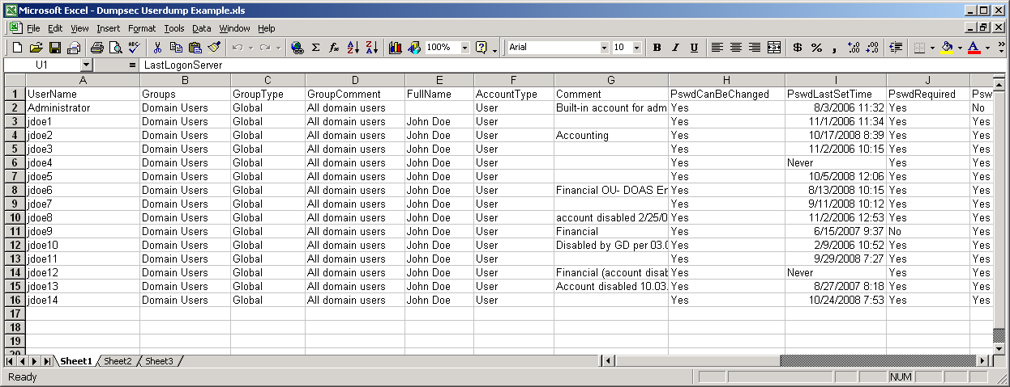
EV9 – nbtscan output and analysis (Task 9). A link should be provided to the Excel analysis of the nbtscan output.

Example output

10.0.3.64 TESTDOMAIN\WGN61 SHARING DC
10.0.3.65 TESTDOMAIN\GA-EX-HR SHARING IIS
EV10 – GetAcct results (Task 10).

----------------------EXAMPLE------------------------
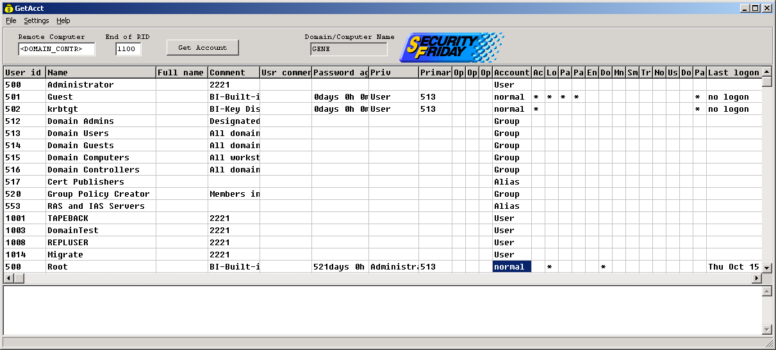

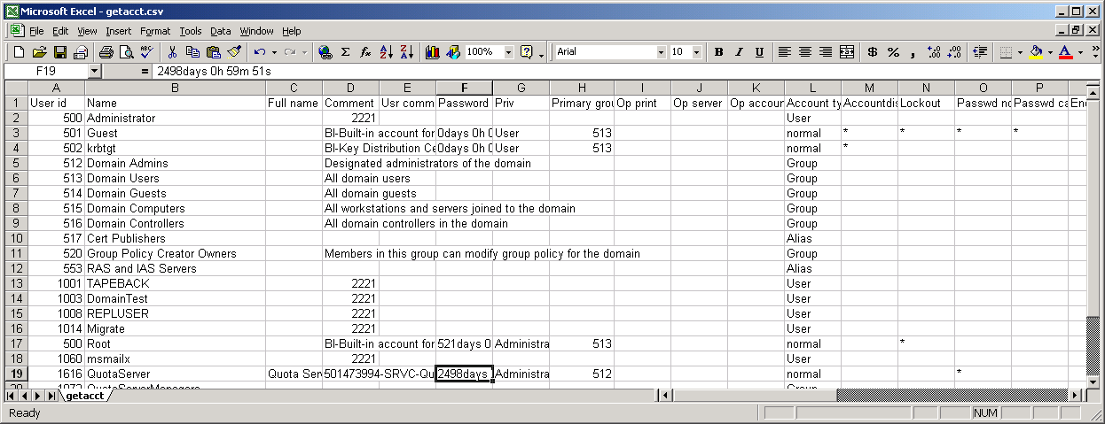

Appendix A: Command Help

ipconfig

C:\>ipconfig /?

USAGE:
ipconfig [/? | /all | /renew [adapter] | /release [adapter] |
/flushdns | /displaydns | /registerdns |
/showclassid adapter |
/setclassid adapter [classid] ]

where
adapter Connection name
(wildcard characters * and ? allowed, see examples)

Options:
/? Display this help message
/all Display full configuration information.
/release Release the IP address for the specified adapter.
/renew Renew the IP address for the specified adapter.
/flushdns Purges the DNS Resolver cache.
/registerdns Refreshes all DHCP leases and re-registers DNS names
/displaydns Display the contents of the DNS Resolver Cache.
/showclassid Displays all the dhcp class IDs allowed for adapter.
/setclassid Modifies the dhcp class id.

The default is to display only the IP address, subnet mask and
default gateway for each adapter bound to TCP/IP.

For Release and Renew, if no adapter name is specified, then the IP address
leases for all adapters bound to TCP/IP will be released or renewed.

For Setclassid, if no ClassId is specified, then the ClassId is removed.

Examples:
> ipconfig ... Show information.
> ipconfig /all ... Show detailed information
> ipconfig /renew ... renew all adapters
> ipconfig /renew EL* ... renew any connection that has its
name starting with EL
> ipconfig /release *Con* ... release all matching connections,
eg. "Local Area Connection 1" or
"Local Area Connection 2"

net

C:\ >net view /?
The syntax of this command is:

NET VIEW
[\\computername [/CACHE] | /DOMAIN[:domainname]]
NET VIEW /NETWORK:NW [\\computername]

browstat

C:\>browstat /?
Usage: BROWSTAT Command [Options | /HELP]
Where <Command> is one of:

ELECT ( EL) - Force election on remote domain
GETBLIST ( GB) - Get backup list for domain
GETMASTER ( GM) - Get remote Master Browser name (using NetBIOS)
GETPDC ( GP) - Get PDC name (using NetBIOS)
LISTWFW (WFW) - List WFW servers that are actually running browser
STATS (STS) - Dump browser statistics
STATUS (STA) - Display status about a domain
TICKLE (TIC) - Force remote master to stop
VIEW ( VW) - Remote NetServerEnum to a server or domain on transport
DUMPNET ( DN) - Display the list of transports bound to browser
Unknown switch specified
In server (or domain) list displays, the following flags are used:
W=Workstation, S=Server, SQL=SQLServer, PDC=PrimaryDomainController,
BDC=BackupDomainController, TS=TimeSource, AFP=AFPServer, NV=Novell,
MBC=MemberServer, PQ=PrintServer, DL=DialinServer, XN=Xenix,
NT=Windows NT, WFW=WindowsForWorkgroups, MFPN=MS Netware,
SS=StandardServer, PBR=PotentialBrowser, BBR=BackupBrowser,
MBR=MasterBrowser, OSF=OSFServer, VMS=VMSServer, W95=Windows95,
DFS=DistributedFileSystem, CLUS=NTCluster, DCE=IBM DSS

enum

C:\>enum
usage: enum [switches] [hostname|ip]
-U: get userlist
-M: get machine list
-N: get namelist dump (different from -U|-M)
-S: get sharelist
-P: get password policy information
-G: get group and member list
-L: get LSA policy information
-D: dictionary crack, needs -u and -f
-d: be detailed, applies to -U and -S
-c: don't cancel sessions
-u: specify username to use (default "")
-p: specify password to use (default "")
-f: specify dictfile to use (wants -D)

nbtscan

C:\>nbtscan
nbtscan 1.0.35 - 2008-04-08 - http://www.unixwiz.net/tools/

usage: nbtscan [options] target [targets...]

Targets are lists of IP addresses, DNS names, or address
ranges. Ranges can be in /nbits notation ("192.168.12.0/24")
or with a range in the last octet ("192.168.12.64-97")

-V show Version information
-f show Full NBT resource record responses (recommended)
-H generate HTTP headers
-v turn on more Verbose debugging
-n No looking up inverse names of IP addresses responding
-p <n> bind to UDP Port <n> (default=0)
-m include MAC address in response (implied by '-f')
-T <n> Timeout the no-responses in <n> seconds (default=2 secs)
-w <n> Wait <n> msecs after each write (default=10 ms)
-t <n> Try each address <n> tries (default=1)
-1 Use Winsock 1 only
-P generate results in perl hashref format

